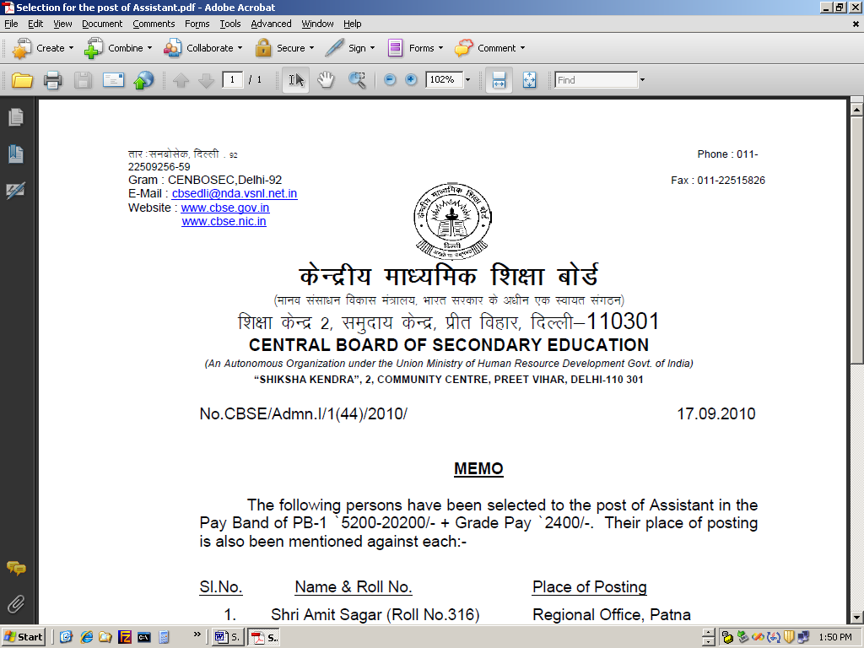
CENTRAL BOARD OF SECONDARY EDUCATION
(An Autonomous Organization under the Union Ministry of Human Resource Development Govt. of India)

“SHIKSHA KENDRA”, 2, COMMUNITY CENTRE, PREET VIHAR, DELHI-110 301

No.CBSE/Admn.I/1(44)/2010/ 17.09.2010

MEMO

The following persons have been selected to the post of Assistant in the Pay Band of PB-1 `5200-20200/- + Grade Pay `2400/-. Their place of posting is also been mentioned against each:-

Sl.No. Name & Roll No. Place of Posting
- Shri Amit Sagar (Roll No.316) Regional Office, Patna
- Shri Ravinder Kumar (Roll No.334) Regional Office, Bhubaneswar
- Shri Manish Kumar (Roll No.336) Regional Office, Bhubaneswar

The offer of appointment in respect of above persons is being issued separately.

Sd/-
(DHARAMPAL SINGH)
Joint Secretary (A&L)

Copy to:
- JS(IT) – with the request to place it on CBSE website
- SO(Admn.I) – with the instruction to issue the officer of appointment immediately.

