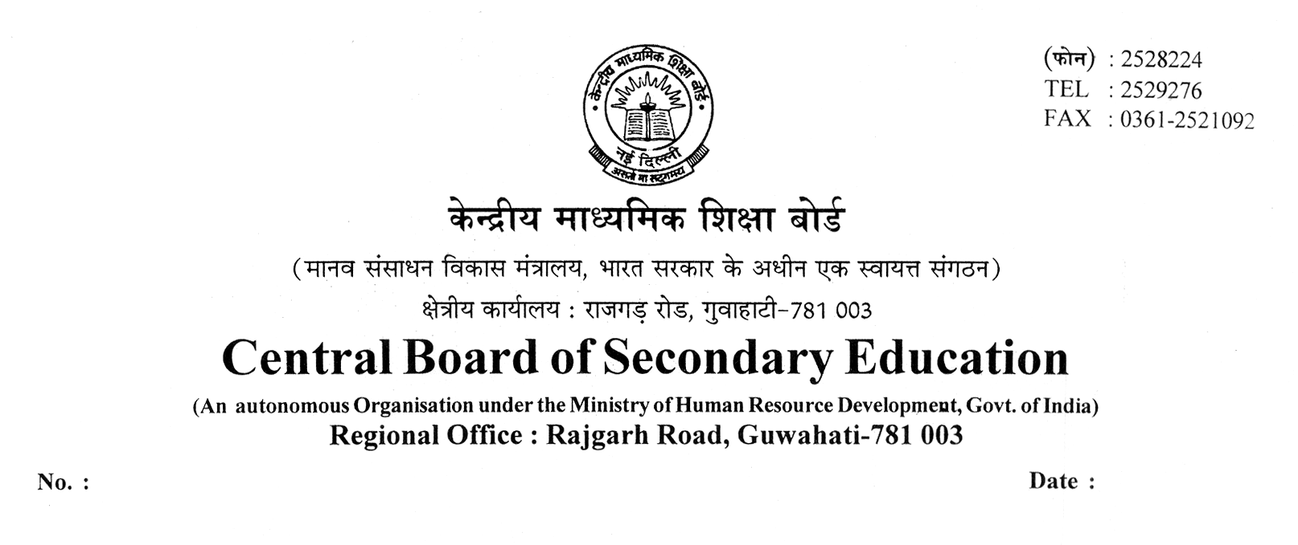
CBSE:GHY:RO(Ghy):Circular(Sub Ex):2009: 18-02-2009

To
All the Principals/Head of the Institution
Of school appearing in AISSE/AISSCE-2009 Exam
Under Guwahati Region.

Sub:- List of Subject Experts in the major subjects for class-XII & X examination 2009.

Sir/Madam,

This is for information and wide circulation among all concerned that the board has engaged Subject Experts from all over the country for finalization of marking scheme in the main subjects for classes XII & X examinations 2009.

In this regard the following subject experts in different major subject(s) have been selected to represent this region in the development/ finalization of marking schemes for 2009 examination.

S No | Subject | Class | Name of Subject Expert | Contact No.
01 | ENGLISH COMM. | X | Mrs. J. Dasbasu, Ex-Principal  House No.2, Vinayak Marg,  Hengrabari Road (opp.Public Health Department)  Guwahati – 781006. | 09435343382 (M)
02 | HINDI | X | Dr. T P Sukla  Vice-Principal  Kendriya Vidyalaya, Maligaon  Guwahati-781011. | 0361-2670796 (O)
03 | MATHEMATICS | X | Sh. B K N Murthy  Principal  Vivekananda Kendra Vidyalaya,  Baragolai, Assam | 03751-221227 (O)  094355/32478 (M)
04 | SCIENCE | X | Dr(Mrs.) S Bhowmik  Ex-Principal  Aastha Apartment, Green Park  Maligaon, Guwahati-781011. | 09435014232 (M)
05 | SOCIAL SCIENCE | X | Smt. Monica Goswami, Principal  Mahaishi Vidya Mandir  Silpukhuri  Guwahati-781003. | 0361-2662559 (O)  094350-40538 (M)
Contd…2.
-Page 2-
06 | ENGLISH CORE | XII | Smt. P Dastidar, Principal  Army School, Narangi  PO Satgaon  Guwahati-781027 | 0361-2642299 (O)  2641024-Fax
07 | HINDI CORE & ELECTIVE | XII | Dr L B Tiwari, Vice-Principal  Army School, Narangi  PO Satgaon, Guwahati-781027 | 0361-2641877 (O)  094350-46246 (M)
08 | MATHEMATICS | XII | Sh. M N Chaturvedi, Principal  Vivekananda Kendra Vidyalaya,  Tinsukia, Assam | 0374-2339236 (O)
09 | PHYSICS | XII | Sh. A K Mishra, Principal  Delhi Public School  Dhaligaon  Dist. Chirang, Assam. | 03664-241078 (O)
10 | CHEMISTRY | XII | Sh. R C Gond, Principal  Kendriya Vidyalaya No.2  Itanagar, Dist. Papum Pare  Arunachal Pradesh-791111 | 0360-2203509 (O)  FAX- 2203509
11 | BIOLOGY | XII | Sh. A K Verma, Principal  Kendriya Vidyalaya  Narangi  Guwahati-781027. | 0361-2640046 (O)  Fax- 2641006
12 | HISTORY | XII | SMt. E C Moore, Principal  Kendriya Vidyalaya  Borjhar  Guwahati-781017 | 09957568740 (M)
13 | POL. SCIENCE | XII | Sh. C O Koshy, Principal  Army School,  Shillong Cantonment,  HQ 101 Area  C/o 99 APO, Meghalaya | 0364-2560603 (O)
14 | GEOGRAPHY | XII | Smt. S Toppo, Principal  Kendriya Vidyalaya,  N F Rly, New Bongaigaon,  Dist. Bongaigoan, Assam | 03664-231653 (O)  Fax- 230948
15 | ECONOMICS | XII | Mrs. Anjana Hazarika, Principal  Kendriya Vidyalaya  Khanapara  Guwahati-781022 | 0361-2361062 (O)  098640-18178 (M)

Any complaint on the question paper (observation schedule) may be sent to the Subject Expert concerned within 24 hours of the conduct of Examinations, so that it can help them in reviewing of the question paper with reference to the standard, difficulty level, length of question paper, maintenance of the syllabus etc. before finalization of marking scheme.

Thanking you,

Yours faithfully,
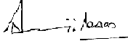

( SANJIB DAS )
ASSISTANT SECRETARY

